

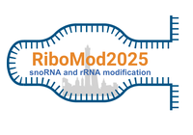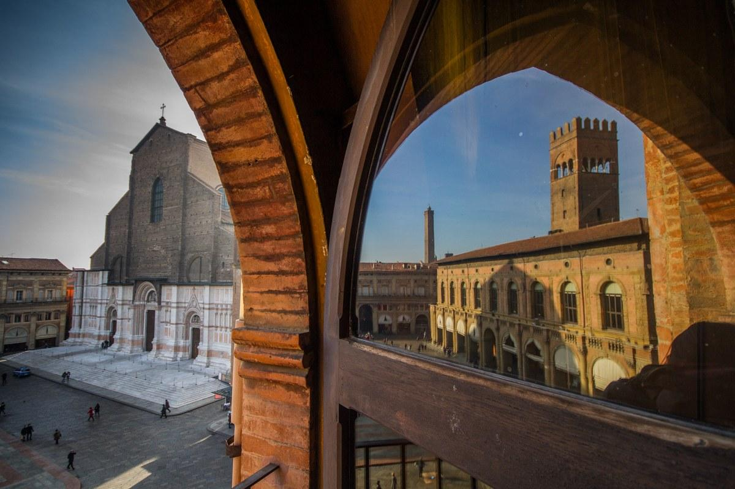

**RiboMod 2025 Travel Fellowship Application Form**

The RiboMod 2025 organizers, in collaboration with the RNA Society, RNA Canada RiboClub, and gold sponsors, are offering a limited number of travel fellowships to support students and postdoctoral fellows who may otherwise be unable to attend the meeting due to financial constraints. Fellowships will typically be awarded in the form of reduced or waived registration fees. Please note that only one fellowship will be granted per research group.

Members of the RNA Society and RNA Canada RiboClub are eligible for additional awards funded by these partners. The number of awards will depend on available funding as of April 10, 2025.

**Application Deadline:** April 10, 2025  
**Notification of Decision:** By April 25, 2025  
**Submission:** Please fill out this form, save it as a PDF, and email it as an attachment to [RiboMod2025@unibo.it](mailto:RiboMod2025@unibo.it). Be sure to include "Travel Fellowship Application" in the subject line of your email.

**Principal Investigator Information**

* **Name:**
* **Email:**
* **Institution:**
* **Department:**
* **Address:**
* **RiboClub / RNA Canada Membership Number (if applicable):**
* **RNA Society Membership Number (if applicable):**

**Applicant Information (Student / Postdoctoral Fellow)**

* **Name:**
* **Email:**
* **Status (e.g., PhD student, Postdoctoral Fellow):**

**Abstract Submission**

**Please confirm you have submitted an abstract through the Ribomod 2025 abstract submission system? Yes/No**

**Statement of Purpose**

**Provide a short paragraph describing your reasons for attending RiboMod 2025, including how the meeting aligns with your research goals (200 words maximum):**

**Research Group Attendance**

* **Will other members of your research group be registering for RiboMod 2025?**
* **If yes, how many?**

**Principal Investigator's Statement**

**Please provide a statement from the Principal Investigator detailing the significance of the work to be presented and the specific contributions of the applicant to this research (300 words maximum):**

Thank you for your interest in RiboMod 2025. We look forward to reviewing your application.